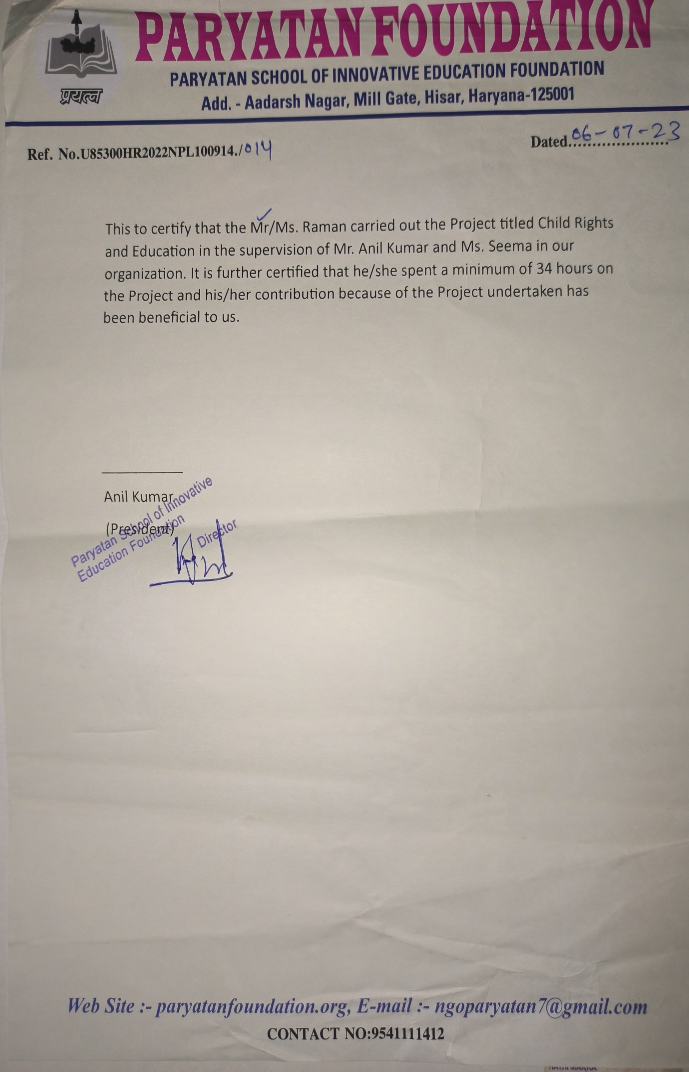**INTRODUCTION**

Through active participation in a community development initiative, I had the incredible chance to create a positive impact in the lives of underprivileged children through education. As I shared my knowledge, their eyes lit up with enthusiasm and a newfound interest in the digital realm. Witnessing them acquire fundamental digital skills, from grasping hardware basics to navigating software, was deeply gratifying. Together, we broke down barriers, empowering these young minds to embrace the boundless possibilities technology presents. By narrowing the digital divide, I take pride in my role in unlocking their inherent potential and paving a path towards a more promising future.

Guided by this experience, my fellow students and I are tasked with the completion of the 'Community Development Project' course, collaborating with Non-Governmental Organization in my locality.

I, **Raman**, with registration number 12215557, undertook collaboration with the NGO "**Paryatan School of Innovation Foundation" in project “*SIKSHA YODHA”* in Hisar, Haryana, India**. The project focuses on the theme of "**Empowering underprivileged children by providing them fundamental Education in field of technology** ". My engagement with the NGO in this project involved a total of 34 hours in offline sessions and 10 hours in online sessions. The NGO is actively involved in providing social services, particularly in the domains of education and empowerment.

During my work in the NGO, I gained something invaluable as well. Teaching these children has taught me **the power of resilience, the importance of empathy, and the transformative impact of education**.

**PROBLEM IDENTIFICATION AND CAUSE OF THE PROBLEM**

The underprivileged and orphaned children in our society face a significant challenge in acquiring basic and digital knowledge. This issue stems from a multifaceted problem involving limited access to resources and opportunities and lack of awareness about why we need education. Many of these children lack access to proper education facilities, including schools equipped with modern tools and technologies. As a result, they are deprived of foundational knowledge that is crucial for their overall development.

Furthermore, the digital aspect of this problem is equally concerning. In today's digital age, having access to technology and digital skills is essential for social and economic inclusion. Unfortunately, these children often lack access to computers, the internet, and other digital resources that have become integral to modern education and communication. This not only widens the educational gap but also hinders their ability to compete in a technology-driven world.

Socio-economic factors play a significant role in exacerbating this problem. Poverty, limited opportunities, and lack of awareness about the importance of digital literacy among parents and communities further perpetuate this divide. Addressing these challenges requires a comprehensive approach that involves providing access to education, technology, and digital training tailored to the needs of underprivileged and orphaned children. Only through concerted efforts can we bridge this gap and empower these children for a better future.

**OBJECTIVE TO BE ACHIEVED**

To effectively address and overcome the issue of the awareness of education through this project, a set of diverse objectives must be attained:

* **Promoting education awareness** involves enlightening communities about the transformative power of learning, fostering a culture where education is valued and pursued by all.
* **Inspiring economically** **disadvantaged children to embrace education entails showcasing success stories** of individuals who transcended similar challenges through learning.
* **Overcome the digital divide**: Grant equitable technology access to underprivileged children, eliminating disparities in the digital era.
* **Enable digital proficiency**: Provide essential expertise to navigate the digital landscape confidently.
* **Expand computer and internet reach**: Secure essential hardware and online connectivity for digital education among the less privileged.
* **Nurture confidence and inquisitiveness**: Cultivate self-assurance, curiosity, and a passion for learning within these youngsters.
* **Promote fairness and inclusiveness**: Disrupt the cycle of inequality by ensuring equal educational and employment opportunities in the digital world.
* **VARIOUS STEPS TAKEN TO ACHIEVE THE OBJECTIVES**
* In our determined effort to bridge the **digital gap and providing them quality education** to disadvantaged children with important digital skills, our NGO has carried out a **well-planned series of activities during my summer break.** Each step was carefully designed to help these young learners gain the knowledge and abilities they need to succeed in the carrier.
* We started off in the **first phase** by introducing them to the **basics of computers**. Knowing how important it is, we taught them about computer parts, how to use **operating systems, and how to fix simple problems**.
* Along with this we discuss their curriculum and I decided to **teach them mathematics and science.** This helped build a strong foundation for their further learning.
* In the following week, we turned our attention to helping them **express their** **creativity**. We showed them how to use computer programs for making pictures, with a special focus on a **program called Paint**.

* + By learning about colors, shapes, and how to use brushes, the kids found out they could make their own art on the computer.
  + We also organize a in which we provide asked them to **make drawing and exhibit them** in art gallery of NGO which contribute to Ngo in term of Money.
* As they got better at using computers, we moved on to teaching them about tools that can help them get things done. In the next week, we showed them important programs **like MS Word, PowerPoint**, and the basics of **Excel**.
* In purpose of entertaining students, we provide **them chess and carrom board to enhance their logical and reasoning abilities**. And consulting them what are the different fields in **which they can make their carrier**.
* During this schedule, making sure they were **interested and involved in learning was really important**. We used activities where they could do things **themselves, worked on projects in groups,** and gave them things to do on their own. This way, they could use what they were **learning** in **real situations**, which helped them understand better and feel more sure of themselves.
* Moreover, witnessing **their eagerness to learn,** the joy on their faces as they accomplished tasks, and their newfound **curiosity** for technology **affirmed** our belief in the power of education and equal opportunities.
* To further enhance their learning experience , we also integrated **online learning platforms** and resources into the program such as *YOUTUBE,UDEMY,COURSERA*. This allowed the children to explore more advanced topics at their own pace, expanding their knowledge beyond the classroom setting. We encouraged their curiosity **and self-directed learning**, providing them with the tools and guidance to navigate the vast digital landscape effectively.
* The activities were designed to promote a holistic approach to the children's development. We included sessions on **digital citizenship, online safety, and responsible internet** usage to instill in them a sense of digital ethics and the importance **of privacy, security, and respectful online behavior**.
* When the program was about to end, we had a party where children **showed their newly learned skills**. They showed their projects that they made using the knowledge they learned. They **showed their projects to their friends, teachers, and other people in the community**. The party was a celebration of their achievements and it inspired them to keep learning about digital skills.
* Throughout the course of this timeline, the **children not only acquired practical digital skills, but also underwent personal growth**. Their confidence was greatly enhanced as they successfully overcame technological challenges and discovered their potential in the digital realm. Furthermore, observing their enthusiasm for learning, the elation evident on their countenances upon completing tasks, and their newfound inquisitiveness towards technology served to reinforce **our conviction in the potency of education and equitable opportunities**.
* I have actively engaged with students in our NGO's educational initiatives by imparting knowledge in mathematics and science. Through dedicated teaching sessions, I have worked tirelessly to enhance the students' understanding and proficiency in these subjects, **contributing to their overall academic growth.** By **employing interactive teaching methods and real-life examples**, I have strived to make complex concepts accessible and interesting for the students. It's been rewarding to witness their enthusiasm for learning flourish, and I am confident that these efforts will have a positive and lasting impact on their education and future endeavors.
* We had a special talk about staying healthy and clean for the kids in our NGO. We talked about things like how to **wash hands properly, taking care of teeth, eating good food, and doing exercises**. We showed them pictures and had fun discussions. We wanted them to know that doing simple **things can make them strong and happy**. The kids were excited to learn, and we hope these lessons will help them stay healthy for a long time .
* India's triumph in the **SAFF football cup, which we watched together at the NGO**, is a wonderful example of teamwork and determination. Just like the players worked hard to win, each of you has **the power to achieve your dreams.** This **victory shows that with effort and a strong spirit**, **even big challenges** can be conquered. Just as we cheered for our team, we believe in each one of you. So remember, no goal is too big if you put your heart into it. Let's learn from our football heroes and strive for success in everything we do!
* Streaming the **Chandrayaan-3 launch at our NGO was a moment of immense pride and inspiration**. Witnessing the advancements of our country's space exploration filled us with awe and excitement. This event **highlighted** **the** **power of science and technology** to reach new frontiers. As we watched the launch together, we aimed to instill the **spirit of curiosity and the belief that nothing is beyond our reach**. It was a remarkable experience that showcased the potential of human innovation. This event at our NGO will forever serve as a reminder that with dedication and exploration, the sky is not the limit – it's just the beginning.
* Dream Bank Project: The "Dream Bank" initiative, under the theme of SIKSHA YODHA, empowers underprivileged children to break free from detrimental habits by encouraging them to save money. This self-help group approach not only in stills financial discipline but also creates a support system for those in need, fostering a brighter future for all.
* Pad Bank Project: Addressing menstrual health, the Pad Bank project is a crucial stride taken by SIKSHA YODHA. By providing essential resources, it ensures the well-being of young women. This purpose effort brings awareness and tangible support to **menstrual health, promoting a compassionate and informed society**.
* Charity Shop: At the heart of SIKSHA Yodha's endeavours lies the **Charity Shop**, a remarkable initiative merging creativity with compassion. Driven by students' artistic expressions, the shop not only showcases their talents but also serves as a platform to raise funds for noble causes. This innovative approach not only fosters a sense of social responsibility but also transforms art into a force for positive change, making education and health accessible to all.
* Over this period, our NGO made a positive impact through various initiatives. We educated students on **staying safe online and taking care of their health**. They learned about washing hands, eating well, and exercising. We also guided them through **their school subjects** and taught them **basic computer skills**. Moreover, we discussed **their future jobs**, helping them think about what they'd like to do. These **efforts aimed to provide well-rounded support**. By focusing on **Internet safety, health habits, academic topics, computer basics, and career ideas**, we aspire to empower these children for a brighter future. Through engaging activities and simple explanations, we're proud of the progress made in **these crucial aspects of their growth.**

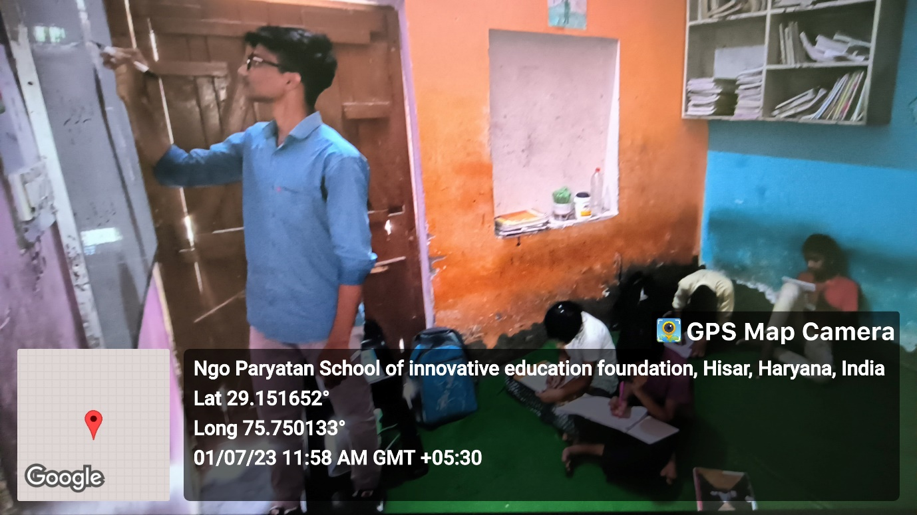

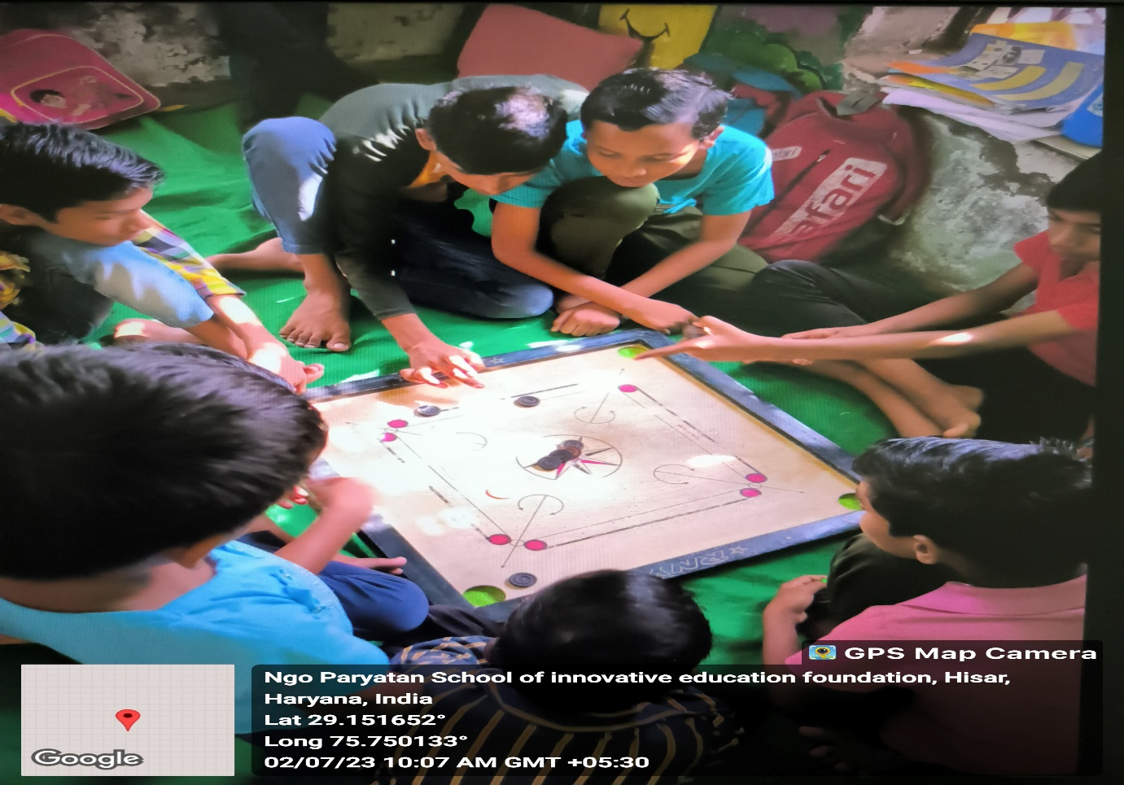

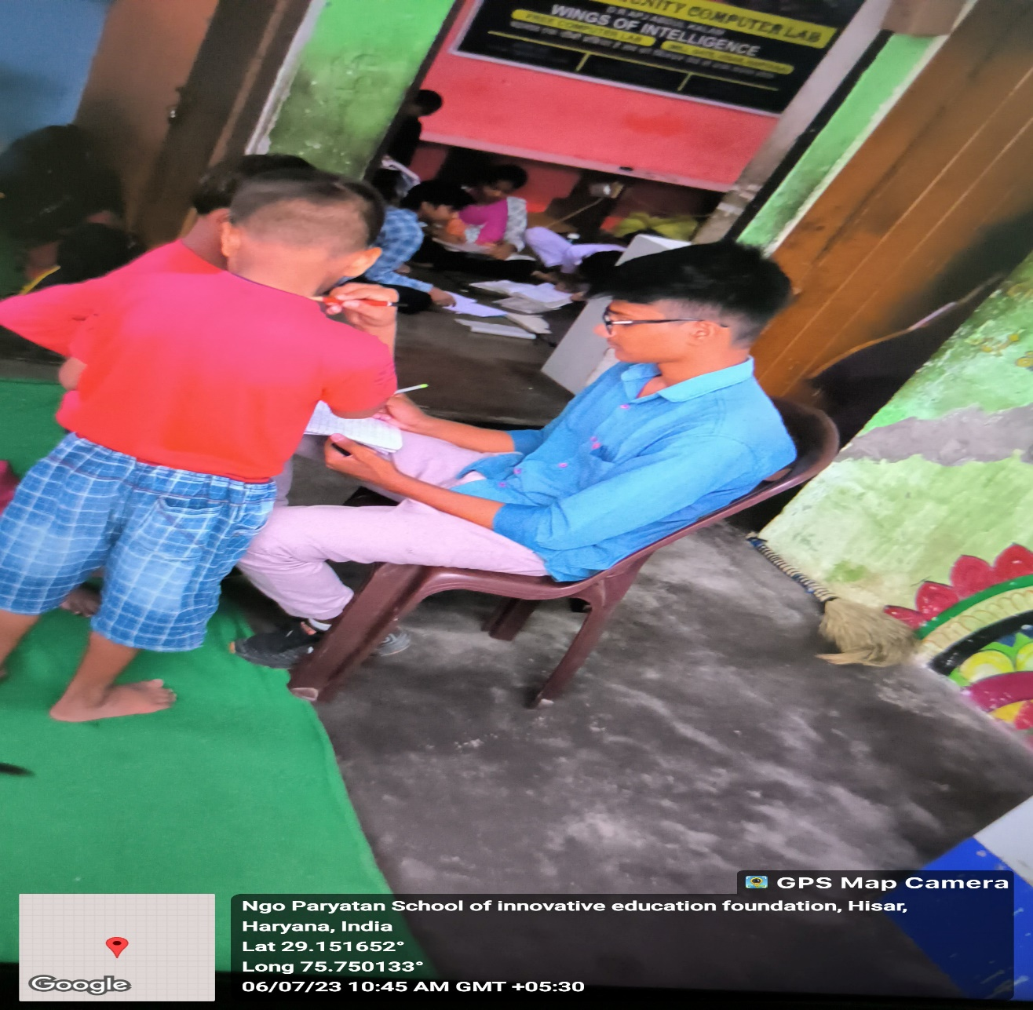

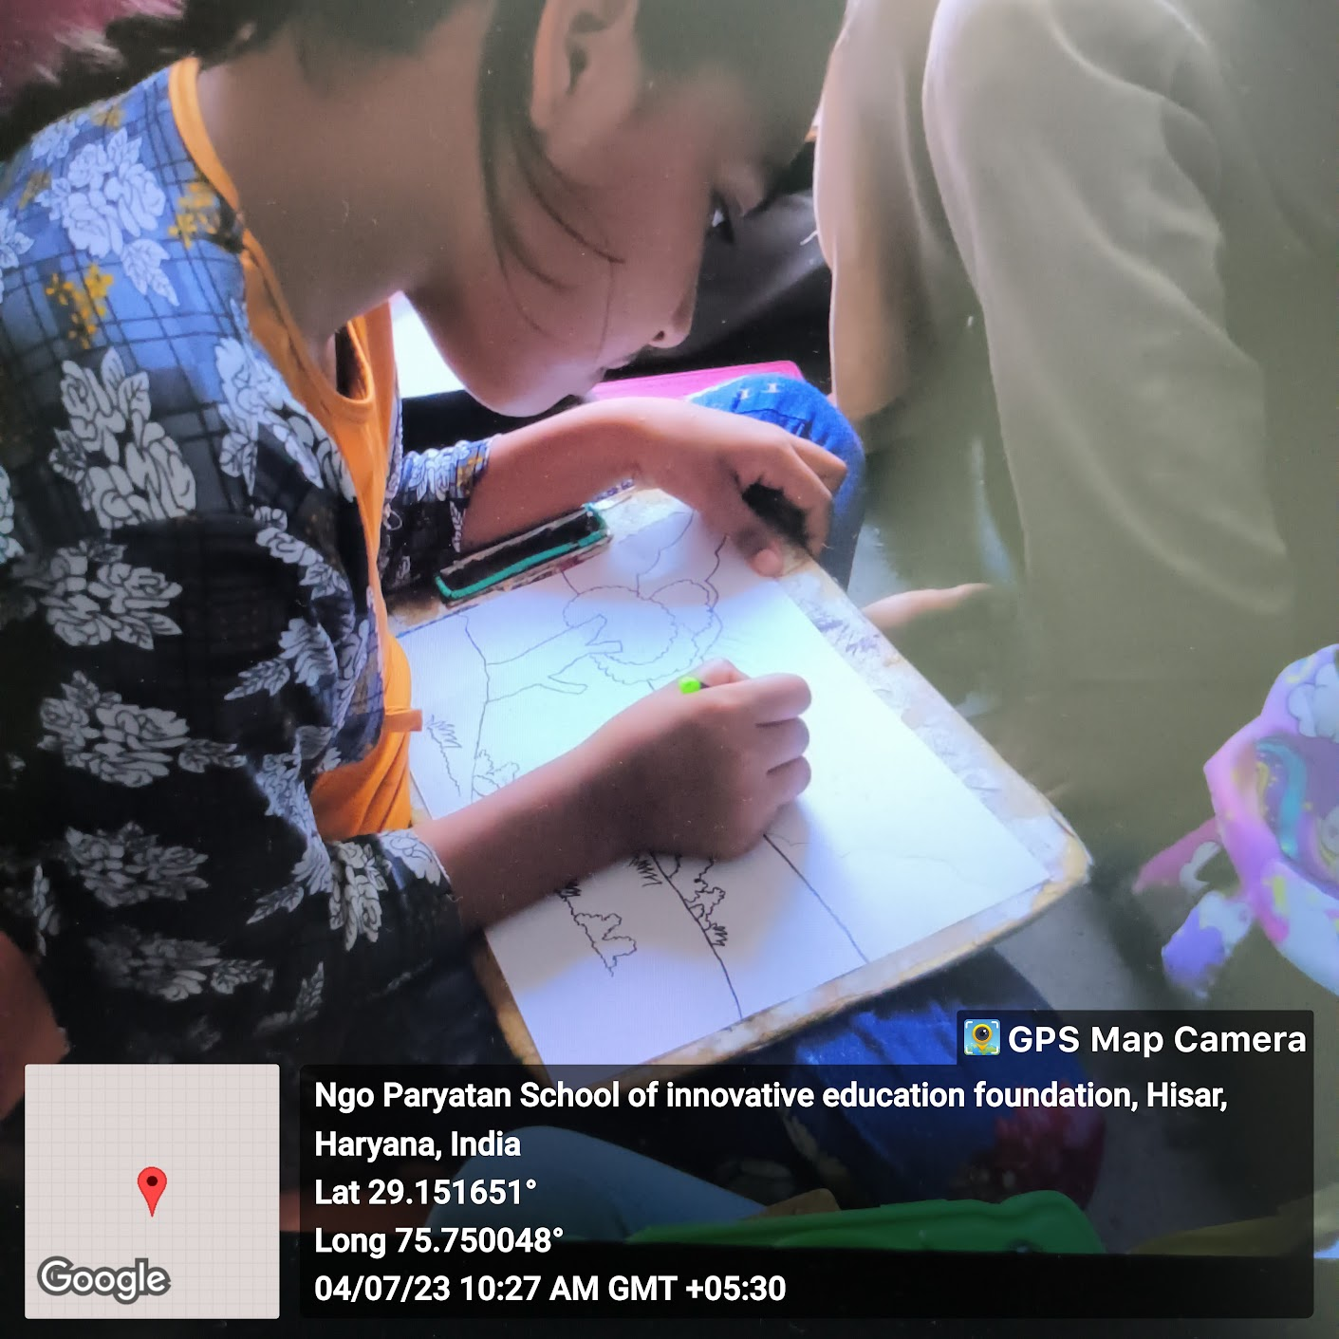

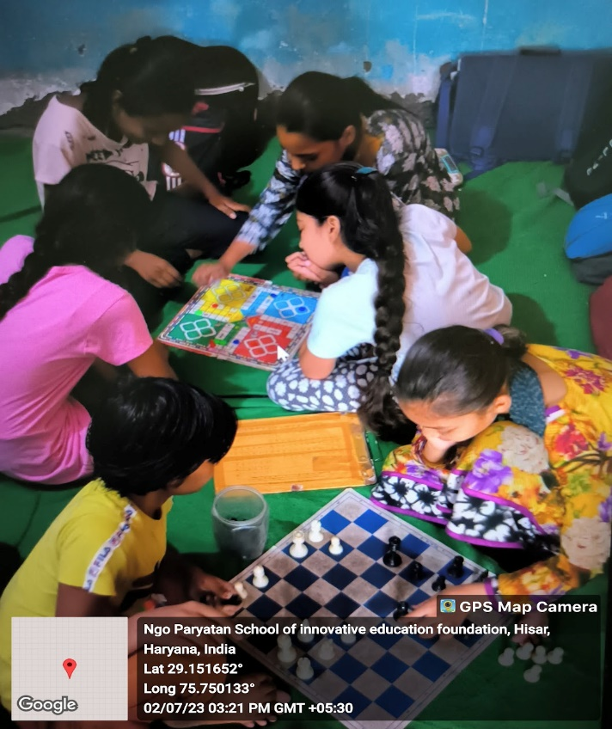

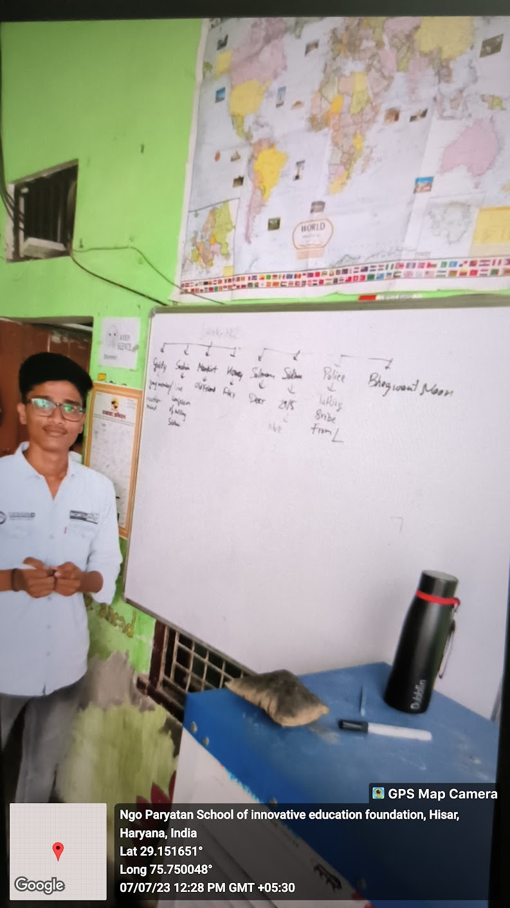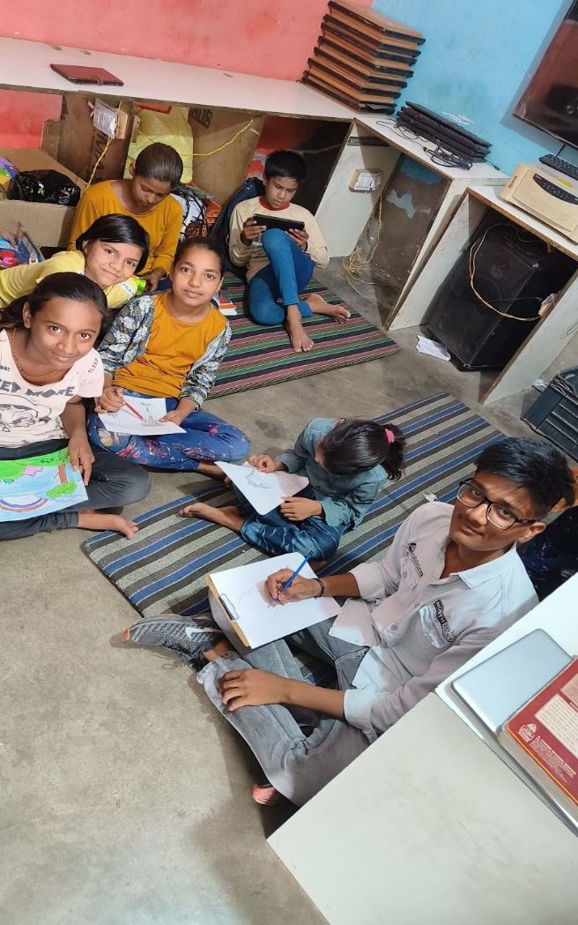

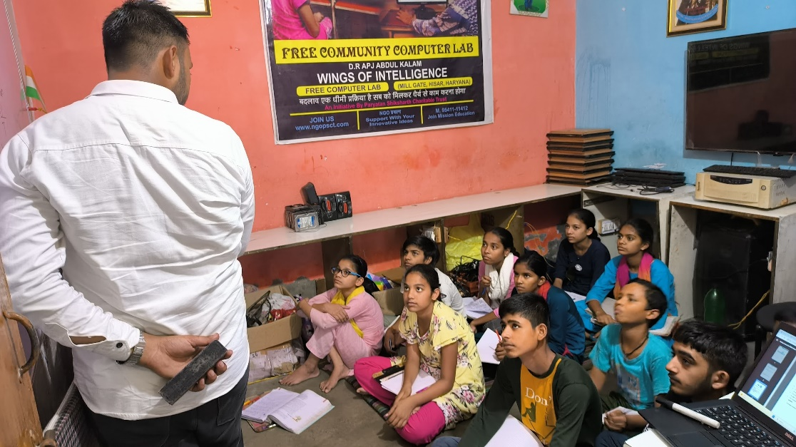

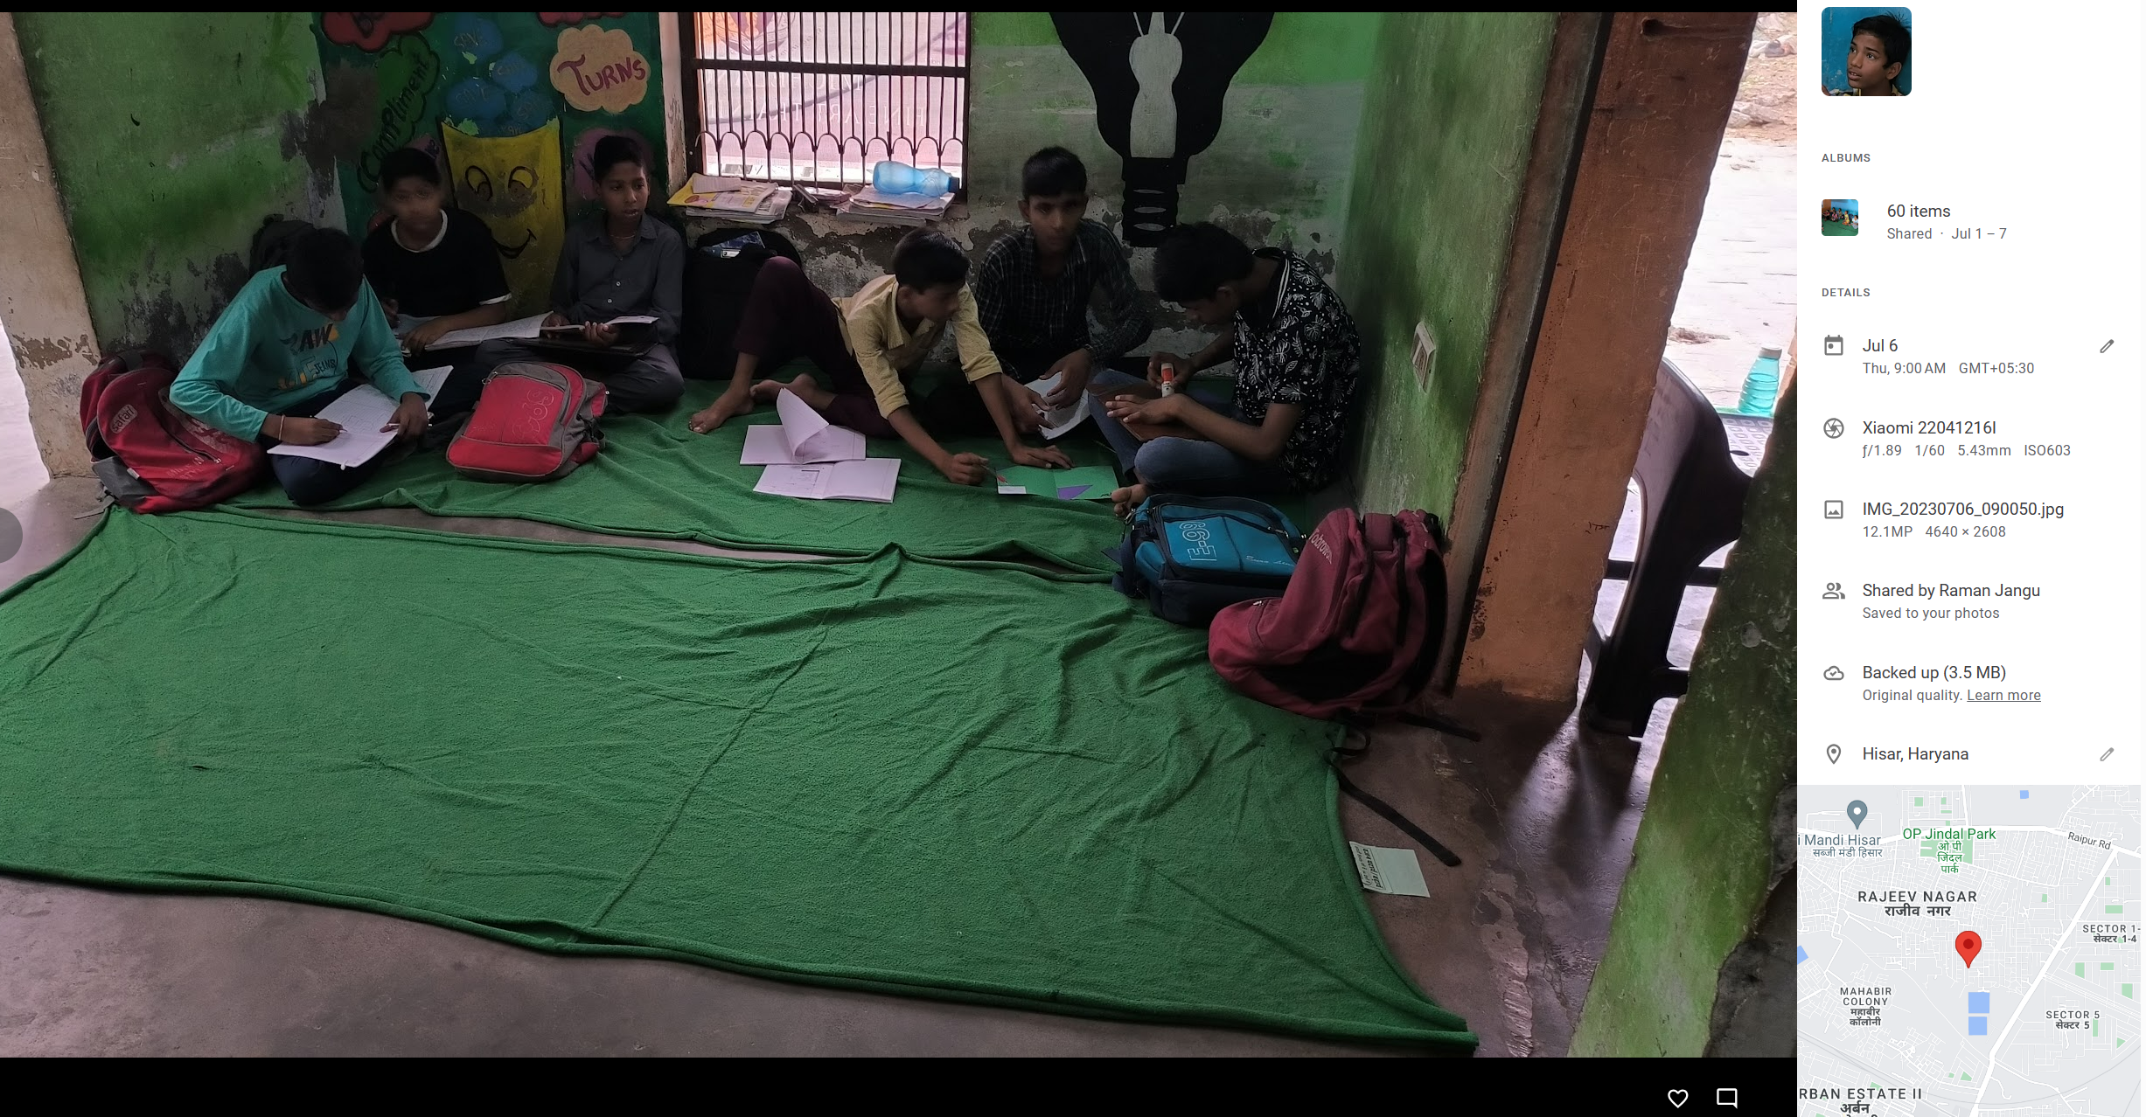

Here is link for more photos and video with location tag :

[*Click here for more photos*](https://photos.google.com/share/AF1QipMHWbs3r1-QdWQfzsiTeHQaUT8SiVDTADrAO5eq3z1ox116IU2R9BmD6aHZPE2TNg?key=X0xCRTBGUzM1Z2o2UFhfUmtDeWpySHV5NnFfT3JB)



**EFFECTIVENESS OF THE PROJECT**

The successful completion of the project *SIKSHA YODHA* had many positive effects which are as follows:

* **Enhancement of Digital Literacy**: The initiative effectively enhanced the children's grasp of digital literacy by introducing them to fundamental computer skills and essential software programs. They acquired knowledge about computer components, operating systems, as well as applications like MS Word, PowerPoint, and Excel. This strong foundation equipped them with practical skills vital for the modern digital era.
* **Creation of Engaging Learning Atmosphere**: The project integrated interactive activities, collaborative projects, and individual tasks, fostering an engaging and participatory learning atmosphere. This approach enabled the children to apply their newfound skills, reinforcing comprehension, and bolstering their self-assurance.
* **Incorporation of Online Learning Resources**: Through the incorporation of online learning platforms and resources, the initiative offered the children opportunities for self-directed learning. They could delve into more advanced subjects at their own pace, expanding their knowledge beyond traditional classroom boundaries.
* **Promotion of Digital Citizenship Values**: The project highlighted the values of digital citizenship, online safety, and responsible internet use. The children received education on digital ethics, privacy, security measures, and courteous online conduct. This emphasis ensured their development of a strong sense of responsibility in the digital realm.
* **Culminating Showcase Event**: The project culminated in a special event where the children presented their projects to their peers, teachers, and local community members. This event celebrated their accomplishments and served as an inspiration for them to continue their journey towards digital empowerment.
* **Personal Learning Experience**: Additionally, I gained insights into the NGO's operations and learned about the organization of social events, broadening my understanding of various aspects beyond the project's scope.

**Identified Societal Problems**

* **Unequal Education** : Many underprivileged kids lack good education, especially digital skills. This puts them at a big disadvantage in today's digital world. Our project helps them learn these skills so they can compete equally with others.
* **Tech Disadvantage** : Technology is growing fast, but some people could be left out because they don't know how to use it. We focus on teaching underprivileged kids digital skills so they aren't left behind. This helps them join the digital world, giving them more opportunities for a better future.
* **Limited Understanding of Education's Value** : Many people don't fully realize how important education is. This lack of awareness can hold back individuals and communities from the benefits education offers. Our project aims to raise this awareness, showing how education can create better opportunities and improve lives.
* **Limited Knowledge about Menstrual Health** : Many people, especially in underprivileged communities, lack proper information about menstrual health. This leads to misunderstandings and challenges related to menstruation. Our project aims to educate and spread awareness about menstrual health, ensuring that everyone has the right knowledge for a healthier life.

CONCLUSION

* **Showing What's Hard for Others**: Our efforts have shown how tough life can be for kids in poor areas. They don't have good schools or computers.
* **Helping Everyone Get Online**: We taught these kids how to use computers. This helps them learn and be a part of the digital world.
* **Working Together with Others**: We teamed up with local groups and people who care about helping these kids. When we work together, we can make big changes.
* **Kids Can Do Great Things**: Meeting these kids taught me that they're strong and brave. Even though life is tough for them, they have lots of potential and can do amazing things.
* **Importance of Computer Skills**: Our efforts highlighted how knowing about computers matters a lot nowadays. It helped kids in need learn something important that can help them do better in life.
* **Building Confidence and Power**: Besides learning about computers, we made these kids feel strong and able to do more. They started to believe in themselves and see a brighter future.
* **Big Positive Change**: Seeing the good things happening because of our efforts has been really great. It showed us how education and helping the community can make a big difference.
* In the end, what we did has taught me that education is important, and it's really good to help kids who don't have as much.